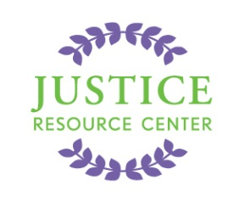
JUSTICE RESOURCE CENTER
122 Amsterdam Avenue
Room 504
New York, New York 10023
www.jrcnyc.org
Tel: (212) 580-5905
Fax: (212) 580-5918
Purchasing Information
Date: September 26, 2013

Purchasing Invoice #: ___

School Name: _________________

Service Name | Service Description | Cost
Project Citizen | JRC offers “Project Citizen,” a public policy program with comprehensive professional development for elementary, middle, ELL, and high schools. As a service-learning program, Project Citizen fits the required service/learning component for all schools. | $685 per class set
Project Citizen | Shipping cost per class set | $15 per class set
 | TOTAL

There are three ways in which you can complete your purchase. Please let us know if you have questions!

- Via Check: Make check payable to “Justice Resource Center, Inc.” and mail to:
The Justice Resource Center
122 Amsterdam Avenue, Room 504
New York, NY 10023

- Using FAMIS as an outside vendor:

- Log into FAMIS

- Click on “Purchasing.”
- “Non-Contracted”
- “Commodities”
- “Sole Vendor “ – Use Justice Resource Center vendor number: 133572161

- Complete purchase by providing your schools information, budget code, etc.

- If you have tax levy or VTEA Funds, you may purchase by doing the following:
(You will need to have funds in the CODE 998 category. Monies can be allocated in code 998)

Log on to Famis

Justice Resource Center Vendor Number: JRC000122

Internal Service Provider Budget Code: 998

JRC Services:
Item Number | Service Name | Service Description and link | Cost
JRC012214 | Project Citizen | JRC offers “Project Citizen,” a public policy program with comprehensive professional development for elementary, middle, ELL, and high schools. As a service-learning program, Project Citizen fits the required service/learning component for all schools.  http://www.jrcnyc.org/docs/jrc012208_pc_fy14.doc | $700.00

Thank you for your purchase. We look forward to partnering with you to deliver your law-related and civic education programs.

