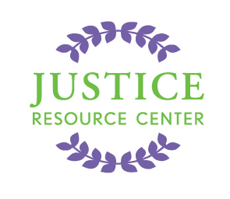
JUSTICE RESOURCE CENTER
122 Amsterdam Avenue
Room 504
New York, New York 10023
www.jrcnyc.org
Tel: (212) 580-5905
Fax: (212) 580-5918

Attention Social Studies, History, Law and Civics Teachers!

Please join us on Tuesday, April 29, 2014 @ 1:00-3:30 PM for
The Constitution Works Professional Development session at the Justice Resource Center
122 Amsterdam Avenue, Room 504, New York 10023

The Justice Resource Center (JRC) is offering an introductory professional development session to educators for The Constitution Works (TCW) program. TCW is a law-related/civics program fostering skills and dispositions for 21st century learners. The program is appropriate for grades 5-12. JRC provides teacher professional development sessions, age-appropriate case materials aligned with Common Core and an opportunity for students to role-play their case in a federal court.

TCW materials were developed around each of the three branches of government. Through engaging fact patterns, students are introduced to relevant constitutional issues and they take on a role in determining the outcome. In the culminating “role play” activity at the majestic Federal Bankruptcy Courthouse, Eastern District, students have the opportunity to assume the role of attorney or Supreme Court Justice in a 1st Amendment case, a Senator applying the 14th Amendment to debate a Bill, or a presidential advisor developing a proposal with constitutional implications.

TCW’s curricular materials include a comprehensive teacher guide with lesson plans and student workbooks. A class set consists of 35 student books and one teacher's manual with a role play at the U.S. Federal Bankruptcy Court in Brooklyn, NY. The cost of the program is $615 per class set. For more information, please visit our webpage.

Agenda:
-Light refreshments and introductions
-Brief overview of TCW
-How classroom lessons are structured: Teacher and Student workbooks
-Discuss skills/knowledge development and Common Core alignment
-Review TCW curricula
-Walk-through role play

*Educators who would like to attend should fill out an application on our webpage and RSVP to Carolyn Morway at cmorway@schools.nyc.gov by Monday, April 28, 2014. We look forward to seeing you there.

The Constitution Works!

