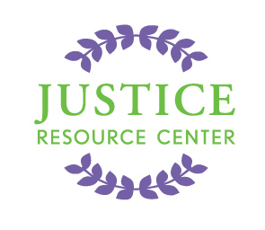
JUSTICE RESOURCE CENTER
122 Amsterdam Avenue
Room 504
New York, New York 10023
www.jrcnyc.org
Tel: (212) 580-5905
Fax: (212) 580-5918

2016 High School International Moot Court Competition at The Hague
Sponsorship Agreement

This program is sponsored by the Justice Resource Center, Inc., in partnership with the City Hall of The Hague. We authorize The Hague to include our corporate name and logo on all “International Moot Court” materials consistent with our sponsorship selection and publication dates.

Please Print

Organization:______________________________________________________

Mailing Address:____________________________________________________

City:________________________________ State:________ Zip:_____________

Contact Person: _____________________________________________________

Phone: _________________________ Email: _____________________________

Select Sponsorship Level:
Diamond Level Sponsor | Donate $100,000 or More Platinum Level Sponsor | Donate $50,000 - $99,999
Gold Level Sponsor | Donate $24,000 - $49,999 Silver Level Sponsor | Donate $10,000 - $23,999
Bronze Level Sponsor | Donate $5,000 - $9,999 Crystal Level Sponsor | Donate $1,000 - $4,999
Quartz Level Sponsor | Donate $300 - $999

Donation Amount: $___________ Justice Resource Center, Inc. is a charitable 501 (c) (3), tax ID: 13-3572161

Authorized Signature:_________________________________ Date:___________

Donation Via:
Enclosed Check Payable to “Justice Resource Center, Inc.”
Airline Miles (Minimum 80,000)
In-Kind Contribution (e.g. Shipping costs); JRC will contact you to make arrangements.

Please Mail Agreement and Payment To:
Debra Lesser
122 Amsterdam Avenue, Room 504
New York, New York 10023

Please Email Your Logo To:
cmorway@schools.nyc.gov

Thank you for your generous support of the 2016 International Moot Court Competition!
You are helping bring law-related and civic education to students in your community and around the world.

