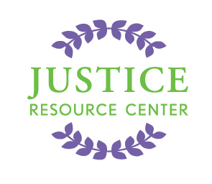
JUSTICE RESOURCE CENTER
122 Amsterdam Avenue
Room 504
New York, New York 10023
www.jrcnyc.org
Tel: (212) 580-5905
Fax: (212) 580-5918
2016 High School International Moot Court at The Hague
Sponsorship Levels
Quartz Level Sponsor | Donate $300 - $999
Thank You's include:
Your organization’s name posted on The Hague and Justice Resource Center websites
A Tax Deductible Donation & Donation Receipt

Crystal Level Sponsor | Donate $1,000 - $4,999
Thank You's include:
Quartz Level Sponsorship Benefits listed above
Your organization’s name in press releases

Bronze Level Sponsor | Donate $5,000 - $9,999
Thank You’s include:
Quartz Level Sponsorship Benefits listed above
Crystal Level Sponsorship Benefits listed above
Your organization’s name on the International Moot Court case materials

Silver Level Sponsor | Donate $10,000 - $23,999
Thank You’s include:
Quartz Level Sponsorship Benefits listed above
Crystal Level Sponsorship Benefits listed above
Bronze Level Sponsorship Benefits listed above
An International Moot Court debate round named after your organization

Gold Level Sponsor | Donate $24,000 – $49,999
Thank You’s include:
Quartz Level Sponsorship Benefits listed above
Crystal Level Sponsorship Benefits listed above
Bronze Level Sponsorship Benefits listed above
Silver Level Sponsorship Benefits listed above
Semi-naming rights for your organization on the International Moot Court brochure

Platinum Level Sponsor | Donate $50,000 - $99,999
Thank You’s include:
Quartz Level Sponsorship Benefits listed above
Crystal Level Sponsorship Benefits listed above
Bronze Level Sponsorship Benefits listed above
Silver Level Sponsorship Benefits listed above
Gold Level Sponsorship Benefits listed above
Your organization’s name and logo on the student t-shirts

Diamond Level Sponsor | Donate $100,000 or More
Thank You’s include:
Quartz Level Sponsorship Benefits listed above
Crystal Level Sponsorship Benefits listed above
Bronze Level Sponsorship Benefits listed above
Silver Level Sponsorship Benefits listed above
Gold Level Sponsorship Benefits listed above
Platinum Level Sponsorship Benefits listed above
Full naming rights on the International Moot Court banner and program

