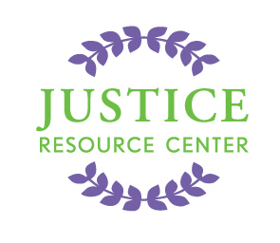
JUSTICE RESOURCE CENTER
122 Amsterdam Avenue
Room 504
New York, New York 10023
www.jrcnyc.org
Tel: (212) 580-5905
Fax: (212) 580-5918

Attention Social Studies, History, Government, Law and Civics Teachers!

Please join us on Monday, September 22, 2014 @ 1:00-3:30 PM for
Project Citizen Professional Development session at the Justice Resource Center
122 Amsterdam Avenue, Room 504, New York 10023

The Justice Resource Center (JRC) is offering an introductory professional development session to educators for the Project Citizen program. Project Citizen is a public policy and civic education program that engages students of all ages in the research and design of a public policy in their community. The program is appropriate for elementary, middle or high school. JRC provides teacher professional development sessions, age-appropriate case materials aligned with Common Core and an opportunity for students to showcase their presentations in front of a panel of judges.

Project Citizen materials were developed around the right of Americans to participate in governing ourselves in order to protect our rights and promote our common welfare. This right carries certain responsibilities, among them being the need to develop the knowledge and skills to participate intelligently and the willingness to promote liberty and justice for all people. This program will add to students’ knowledge, enhance their research, writing and speaking skills, and deepen their understanding of how we can all work together to make our communities better.

After choosing a local public policy issue, students will: identify a problem with the policy; research alternative policies; create and propose their own policy solution; and design an action plan to implement their proposal. Students create a four-part display board with each of the above features. Additionally, students compile a literacy-based portfolio binder that documents their research. Upon successful completion of a Project Citizen portfolio, students will participate in a school-level showcase. School-level winners will then have the opportunity to participate in a citywide showcase event in May-June 2015.

Project Citizen’s curricular materials include a comprehensive teacher guide with lesson plans and student workbooks. A class set consists of 35 student books and one teacher's manual with a school showcase. Teachers will also be invited to a Project Citizen Professional Development check in mid-way through the project timeline. The cost of the program is $700 per class set. For more information, please visit our Project Citizen webpage.

Agenda:
-Light refreshments and introductions
-Brief overview of Project Citizen
-Discussion and small-group activities
-Brainstorming topics and group discussion
-Designing a portfolio
-Connect skills/knowledge development to Common Core

*Educators who would like to attend should RSVP to Carolyn Morway at cmorway@schools.nyc.gov by Friday, September 19, 2014. We look forward to seeing you there!

