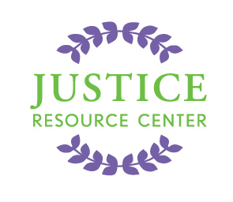
JUSTICE RESOURCE CENTER
122 Amsterdam Avenue
Room 504
New York, New York 10023
www.jrcnyc.org
Tel: (212) 580-5905
Fax: (212) 580-5918

Project Citizen Professional Development Application
Monday, September 22, 2014 @ 1:00-3:30 PM
Justice Resource Center
122 Amsterdam Avenue, Room 504, New York 10023

Name:

Name of School:

School Address:

Zip Code: _______________

Email: Cell Phone #

School Phone #: School Fax #:

Grade Level: Subject(s) Taught:

Principal:

1. Please describe the law-related/civic education/social studies courses you are currently teaching. __________________________________________________________________________________________________________________________________________________________________________________________________________________________________________________________________________________________________________________________________________________________________________________________________________________________________________________________________________________________________________

2. Please explain what you hope to gain from attending this workshop.
______________________________________________________________________________________________________________________________________________________________________________________________________________________________________________________________________________________________________________________________________________________________________________________________________

3. Have you participated in any other JRC programs? If so, please explain.
____________________________________________________________________________________________________________________________________________________________________________________________________

Assistant Principal’s Name (Print)

Assistant Principal’s Signature

Date:_________________________

This application MUST be completed and emailed to Carolyn Morway at cmorway@schools.nyc.gov or printed and faxed to 212-580-5918 by September 19, 2014. A confirmation email will be sent upon receipt.

