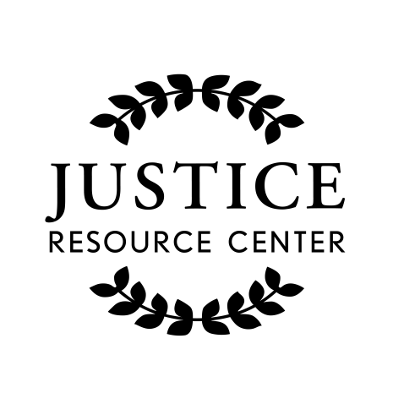
JUSTICE RESOURCE CENTER
122 Amsterdam Avenue
Room 504
New York, New York 10023
www.jrcnyc.org
Tel: 212.580.5905
Fax: 212.580.5918

James Madison Legacy Program
2017 Summer Institute at the Thurgood Marshall U.S. Courthouse
June 29, 30 and July 5, 6, 7
Teacher Application

Name: ____________________________________________________________________________________________
School: ____________________________________________________________________________________________
School District: _____________________________________________________________________________________
School Address: _____________________________________________________________________________________
______________________________________________________________________________________
School Phone: ______________________________________________________________________________________
Home Address: _____________________________________________________________________________________
_______________________________________________________________________________________
Home Phone:_____________________________ Email: ____________________________________________________
Cell:_______________________________________________________________________________________________
Teaching Assignment/classes:________________________________ Grade(s): ________ Approx. # of Students:_______
Please describe the high needs students enrolled at your school (not necessarily your classes). Please see the attached letter for definition of “high needs.”
__________________________________________________________________________________________________
__________________________________________________________________________________________________
__________________________________________________________________________________________________
__________________________________________________________________________________________________
Why should you be selected for this Summer Institute? Have you participated in any previous “We the People” Professional Development sessions? If yes, please describe.
__________________________________________________________________________________________________
__________________________________________________________________________________________________
__________________________________________________________________________________________________
__________________________________________________________________________________________________

Please email this preliminary application to jrcinfo@schools.nyc.gov by May 18, 2017

